Explore a retail revolution with Shopkeeper—an intuitive app redefining stock and point-of-sale dynamics. With a user-friendly interface, real-time reporting, and secure Firebase integration, it adapts seamlessly to various businesses. Shopkeeper isn't just an app; it's your gateway to streamlined inventory control and an enhanced retail experience. Embrace efficiency and engagement with Shopkeeper.

Muhammad Areeb Dayo

**SHOP KEEPER INVENTORY APP.**

REPORT.

**TITLE: SHOPKEEPER INVENTORY & POS APP.**

**Course: MOBILE APPLICATION DEVELOPMENT**

**Faculty: DANIYAL NAWAZ Slot: MONDAY 6:30-9:30**

**GROUP MEMBERS & PREFERRED ROLES.**

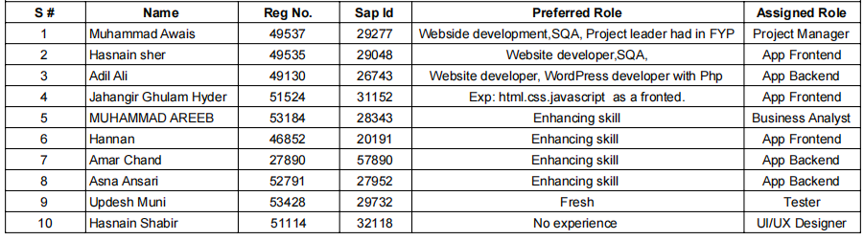

**TABLE OF CONTENTS.**

**Abstract…………………………………………………………………………………….3**

**Introduction………………………………………………………………………………..4**

**Acknowledgment…………………………………………………………………………..5**

**Executive Project Summary ………………………………………………………………6**

**Literature Review………………………………………………………………………….7**

**Objectives…………………………………………………………………………………..8**

**Functional Features ……………………………………………………………………….9**

**Non-Functional Features………………………………………………………………....10**

**System Architecture.………………………………………………………………………11**

**Development Process………………………………………………………………………14**

**Challenges & Solution……………………………………………………………………..15**

**Conclusion…………………………………………………………………………………..17**

**User Flow Er Diagram …………………………………………………………………….18**

**Controller Flow Er Diagram……………………………………………………………....19**

**Ui/Ux………………………………………………………………………………………...20**

**ABSTRACT.**

The Shopkeeper Inventory and POS App is a versatile and user-friendly mobile solution crafted to redefine inventory control and streamline point-of-sale operations for businesses. Integrating critical functionalities such as CRUD operations, reporting, billing, and seamless data export through Firebase, the app delivers a comprehensive approach to efficient stock management.

Users can effortlessly add, delete, update, and view items, ensuring real-time accuracy in inventory tracking. The reporting feature empowers users to generate customizable reports, facilitating data-driven decision-making based on stock levels and sales trends.

The robust billing system simplifies transaction management, while data export to Firebase guarantees secure and accessible storage. Leveraging Firebase APIs for authentication, real-time database management, storage, and analytics, the Shopkeeper Inventory and POS App stands as a powerful and forward-thinking tool for businesses to optimize their stock operations and enhance the overall retail experience.

**INTRODUCTION.**

Introducing the Shopkeeper Inventory and POS App—a revolutionary mobile solution designed to transform stock management and retail operations. With a user-friendly interface, seamless CRUD operations, and real-time reporting, the app ensures accurate and efficient inventory control. The robust billing system simplifies transactions, while Firebase integration guarantees secure data storage and accessibility. Leveraging Firebase APIs for authentication and analytics, Shopkeeper stands as a powerful tool, providing businesses with a dynamic and intuitive platform to optimize stock operations and elevate the overall retail experience.

Beyond its core features, Shopkeeper adapts to diverse business models, offering customization options for retail stores, cafes, boutiques, and more. The app's versatility is complemented by a real-time analytics dashboard, empowering business owners with insights into performance metrics, sales trends, and inventory turnover. Its integration of machine learning capabilities further enhances forecasting accuracy, anticipating stock demands based on historical data.

Shopkeeper is not just a tool for inventory management; it's a transformative solution, redefining how businesses engage with their customers. Its commitment to user-centric design, data security, and cutting-edge features makes it an indispensable asset for businesses seeking to revolutionize their retail ecosystem. Embrace Shopkeeper and discover a new era in inventory management and customer interaction.

**ACKNOWLEDGEMENT.**

We would like to express our heartfelt gratitude to all those who have contributed to the development and realization of this project. First and foremost, we extend our sincere thanks to “**sir Daniyal Nawaz”**, our mentor and guide, for providing invaluable insights, guidance, and unwavering support throughout the journey.

We are grateful to the entire our MPD project Team for their collaboration, encouragement, and collective effort in bringing this project to fruition. Special thanks to “**sir Daniyal Nawaz”** for their dedicated contributions.

We also want to acknowledge the support of our families and friends who stood by us during the challenges and milestones of this project. Their encouragement and understanding were pivotal in keeping us motivated.

Last but not least, we extend our appreciation to all those whose work, research, or insights have influenced and shaped this project. Your contributions have been instrumental in its development.

Thank you all for being part of this journey and for making this project a reality.

**EXECUTIVE PROJECT SUMMARY.**

The Shopkeeper Inventory and POS App is a revolutionary mobile solution designed to enhance stock management and retail operations. With a focus on user-friendly design and seamless integration of features such as CRUD operations, real-time reporting, secure billing, and Firebase functionalities, the app aims to provide businesses with a comprehensive platform for efficient inventory control and an elevated retail experience. The project's key goals include prioritizing a user-centric interface, offering versatility for diverse business models, and ensuring scalability to adapt to evolving industry needs. In summary, the Shopkeeper app aspires to set a new standard in modern retail applications by combining advanced features with innovative technology for optimal stock management and customer engagement.

**LITERATURE REVIEW.**

Extensive research in retail underscores the critical role of efficient inventory management and point-of-sale (POS) systems. Studies often delve into models like just-in-time (JIT) and ABC analysis to optimize supply chain dynamics and minimize costs. Integrating POS systems with inventory management is crucial for real-time updates on sales, stock levels, and transaction data. User-centric design principles, focusing on user experience and interface design, impact employee productivity and customer satisfaction. Emerging technologies, including cloud-based solutions and mobile applications, are researched for their role in enhancing flexibility and scalability. Data security and compliance with industry regulations are emphasized to ensure secure transactions and customer privacy. Analytics and business intelligence tools integrated with inventory and POS systems provide actionable insights into consumer behavior, pricing strategies, and decision-making processes. Efficient inventory practices contribute to streamlined supply chain operations, reducing lead times and overall operational costs. With the rise of mobile and omni-channel retailing, ongoing research explores strategies for adapting inventory and POS systems to multi-channel sales, addressing challenges in synchronizing inventory across various channels for a unified customer experience. The dynamic retail landscape continues to drive research for innovative technologies and strategies, ensuring the continuous optimization of inventory management and POS systems.

Moreover, the literature highlights the significance of technology adoption in retail, with a focus on the transition from traditional systems to cloud-based solutions. Researchers delve into the benefits and challenges associated with this shift, emphasizing the need for retail businesses to embrace scalable and cost-effective solutions. The mobile and omni-channel retailing era has prompted investigations into strategies for synchronizing inventory and POS systems across various channels seamlessly. The integration of data analytics not only offers insights into consumer behavior but also facilitates predictive modeling for inventory optimization. As retail continues to evolve, ongoing research explores innovative technologies and methodologies, aiming to enhance the adaptability, efficiency, and overall performance of inventory management and POS systems.

**OBJECTIVES.**

The objective of the Shopkeeper Inventory and POS App project is to develop and implement a cutting-edge mobile solution that revolutionizes the traditional approach to stock management and retail operations. The primary goals are:

1. **Efficiency in Stock Management**:

Intuitive platform that enables businesses to efficiently manage their stock through seamless CRUD operations, ensuring real-time accuracy in inventory tracking.

1. **Enhanced Retail Experience:**

Elevate the overall retail experience by providing a user-friendly interface, incorporating features such as real-time reporting, and implementing a secure billing system to simplify transactions.

1. **Integration of Firebase Technology:**

Leverage Firebase APIs for authentication, real-time database management, storage, and analytics to ensure secure data storage and accessibility, setting the foundation for a robust and scalable application.

1. **Versatility and Customization:**

Tailor the app to meet the diverse needs of various businesses by offering customization options, making it adaptable to different industry models and business requirements.

1. **Scalability:**

Design the app with scalability in mind, allowing it to evolve with changing business demands and industry trends.

1. **User-Centric Design:**

Prioritize a user-centric design to make the app accessible across various technical expertise levels, enhancing usability and user satisfaction.

1. **Setting a Standard:**

Aspire to set a new standard in modern retail applications by combining advanced functionalities with innovative technology, creating a comprehensive solution that optimizes stock operations and customer engagement.

**FUNCTIONAL FEATURES.**

1. **Effortless CRUD Operations:**

Seamlessly add, delete, update, and view items for real-time accuracy in inventory tracking.

1. **Real-time Reporting:**

Customizable reports to empower data-driven decision-making based on stock levels and sales trends.

1. **Secure Billing System:**

Simplify transaction management through an intuitive and robust billing system, enhancing the point-of-sale experience.

1. **Firebase Integration:**

Ensure secure data storage and accessibility by leveraging Firebase for authentication, real-time database management, storage, and analytics.

1. **User-Friendly Interface:**

Prioritize a user-centric design to enhance accessibility across various technical expertise levels, ensuring an intuitive and seamless user experience.

1. **Versatility for Business Models:**

Customize the app to meet the diverse needs of different businesses, providing adaptable solutions for retail stores, cafes, boutiques, and more.

1. **Scalability:**

Design the app to be adaptable and scalable, allowing it to evolve with changing business requirements and industry trends.

1. **Machine Learning Integration:**

Utilize machine learning capabilities for predictive analytics, anticipating stock demands based on historical data to optimize inventory levels.

1. **Multi-Platform Accessibility:**

Enable accessibility across various platforms, including smartphones and tablets, to facilitate on-the-go stock management and transactions.

1. **Real-time Analytics Dashboard:**

Incorporate a dynamic analytics dashboard to offer business owners insights into performance metrics, sales trends, and inventory turnover in real-time.

1. **Setting Standards in Retail Technology:**

Aspire to set a new standard in modern retail applications by combining advanced features with innovative technology, providing a comprehensive solution for optimized stock operations and customer engagement.

1. **Multi-Platform Accessibility:**

Enable access across various devices, including smartphones and tablets.

**NON-FUNCTIONAL FEATURES:**

1. **Security:**

Ensure data security through Firebase integration and industry-standard encryption protocols.

1. **Performance:**

Optimize app performance for quick response times and efficient data processing.

1. **Reliability:**

Build a reliable system that minimizes downtime and ensures continuous availability.

1. **Usability:**

Prioritize a user-friendly design to enhance ease of use and accessibility.

1. **Scalability:**

Design the app architecture to handle increased data and user load as the business grows.

1. **Interoperability:**

Ensure compatibility with other systems and technologies commonly used in retail environments.

1. **Compliance:**

Adhere to industry standards and regulations governing data protection and retail operations.

1. **Maintainability:**

Facilitate easy maintenance and updates to ensure the app's longevity and adaptability.

1. **Documentation:**

Provide comprehensive documentation for developers, users, and administrators.

1. **Performance Monitoring:**

Implement monitoring tools to track and analyze app performance, ensuring optimal functionality.

**SYSTEM ARCHITECTURE.**

The Shopkeeper Inventory and POS App's system architecture is designed to deliver a robust and scalable solution for efficient stock management and retail operations. The architecture comprises several key components, each playing a vital role in ensuring seamless functionality.

1. **Client-Side Application**:

The client-side application serves as the user interface, accessible through various platforms such as smartphones and tablets. It interacts with the server-side components to request and display data, manage user input, and facilitate a smooth user experience.

1. **Server-Side Application:**

The server-side application is responsible for processing client requests, executing business logic, and managing the interaction with the database. It ensures the real-time execution of CRUD operations, report generation, and billing processes.

1. **Firebase Integration:**

Firebase is integrated into the architecture to handle authentication, real-time database management, storage, and analytics. It ensures secure data storage, user authentication, and facilitates real-time updates to keep the application synchronized.

1. **Database:**

The database component stores and manages the app's data, including stock information, transaction records, and user details. It is designed to support efficient data retrieval and storage, contributing to the real-time functionality of the application.

1. **Machine Learning Module:**

The machine learning module is integrated to provide predictive analytics for optimizing inventory levels. Leveraging historical data, it anticipates stock demands and assists in maintaining an optimal balance.

1. **Reporting Engine:**

The reporting engine component handles the generation of customizable reports. It extracts relevant data from the database, processes it based on user preferences, and delivers comprehensive reports for data-driven decision-making.

1. **Authentication Services:**

Authentication services ensure secure access to the application, validating user credentials and authorizing actions based on user roles and permissions. Firebase Authentication is utilized to enhance security.

1. **Analytics Dashboard:**

The analytics dashboard component provides real-time insights into performance metrics, sales trends, and inventory turnover. It enhances business intelligence and aids in strategic decision-making.

1. **Communication Middleware:**

The communication middleware facilitates seamless communication between different components, ensuring data flows efficiently across the system. It contributes to the real-time synchronization of data.

1. **External Integrations:**

External integrations enable compatibility with other systems and technologies commonly used in retail environments. This ensures interoperability and a cohesive retail ecosystem.

1. **Front-End:**

The front-end of the Shopkeeper app serves as the user interface, providing a seamless and intuitive experience for users. Key elements include:

* **User Interface (UI):** The UI is designed for accessibility and ease of use, featuring a clean layout, intuitive navigation, and visually appealing design elements.
* **Client-Side Application:** The client-side application is responsible for rendering the UI on various devices, including smartphones and tablets. It facilitates user interactions, manages input, and communicates with the back-end to request and display data.
* **Reporting Interface:** The reporting interface allows users to generate customizable reports, providing valuable insights into stock levels, sales trends, and other relevant metrics.
* **Billing System UI:** The billing system UI handles transaction-related activities, allowing users to create invoices, manage receipts, and conduct seamless point-of-sale transactions.
* **Authentication Interface:** The authentication interface enables users to securely log in, protecting the application and ensuring that only authorized personnel can access sensitive information.

1. **Back-End:**

The back-end of the Shopkeeper app consists of server-side components that handle data processing, business logic, and interactions with databases and external services

* **Server-Side Application:** The server-side application processes client requests, executes business logic, and manages the flow of data between the front-end and the database.
* **Database Management System (DBMS):** The DBMS stores and manages the application's data, including information about stock items, transactions, and user details. It supports efficient data retrieval and storage.
* **Firebase Integration:** Firebase integration enhances the back-end by providing services such as authentication, real-time database management, storage, and analytics. It ensures secure data storage and facilitates real-time updates.
* **Machine Learning Module:** The machine learning module, part of the back-end, processes historical data to provide predictive analytics. It aids in optimizing inventory levels by anticipating stock demands.
* **Authentication Services:** Authentication services verify user credentials, ensuring secure access to the application. It controls user permissions and roles, enhancing the overall security of the system.
* **Communication Middleware:** The communication middleware facilitates smooth communication between different components of the back-end, ensuring efficient data flow and synchronization.
* **External Integrations:** External integrations enable compatibility with other systems and technologies commonly used in retail environments. This ensures interoperability and a cohesive retail ecosystem.

**DEVELOPMENT PROCESS.**

The development of the Shopkeeper Inventory and POS App follows a systematic and iterative process, incorporating best practices to ensure the creation of a robust and user-friendly solution. The development lifecycle can be outlined as follows:

1. **Requirements Analysis:**

Gather and analyze key features and business objectives.

1. **Design Phase:**

Architect the system, design UI, and define the database schema.

1. **Front-End Development:**

Build an intuitive and responsive user interface.

1. **Back-End Development:**

Develop server-side logic, integrate databases, and implement Firebase services.

1. **Database Implementation:**

Set up and optimize the database for efficient data handling.

1. **Machine Learning Integration:**

Integrate machine learning for predictive analytics on inventory levels.

1. **Testing:**

Conduct thorough testing, addressing identified issues.

1. **Deployment:**

Deploy to staging and then to the production environment.

1. **Monitoring and Optimization:**

Implement monitoring tools and optimize performance based on insights.

1. **Documentation:**

Create comprehensive documentation for users and administrators.

1. **Training and Support:**

Conduct training sessions and establish a support system.

1. **Continuous Improvement:**

Gather feedback and implement regular updates for ongoing improvement.

**CHALLENGES AND SOLUTIONS.**

1. **Integration Complexity:**

* **Challenge:** Integrating various components like Firebase, machine learning, and external services can be complex.
* **Solution:** Adopt a modular approach, ensuring clear interfaces and thorough testing during integration phases.

1. **Security Concerns:**

* **Challenge:** Safeguarding sensitive data, especially during transactions and storage.
* **Solution:** Implement robust encryption, secure authentication, and regular security audits to identify and address vulnerabilities.

1. **User Interface Optimization:**

* **Challenge:** Balancing a feature-rich UI with simplicity for diverse users.
* **Solution:** Conduct usability testing, gather user feedback, and iterate on the design for an intuitive interface.

1. **Scalability Demands:**

* **Challenge:** Meeting the scalability requirements as the user base grows.
* **Solution:** Design the architecture with scalability in mind, employ cloud services, and regularly assess performance metrics for optimization.

1. **Machine Learning Accuracy:**

* **Challenge:** Ensuring the accuracy of machine learning predictions for optimal inventory management.
* **Solution:** Train the model with quality data, fine-tune algorithms, and continuously update the model based on real-world performance.

**\**

1. **User Adoption:**

* **Challenge:** Ensuring user adoption and providing adequate training.
* **Solution:** Offer comprehensive training sessions, create user-friendly documentation, and provide ongoing support channels.

1. **Data Migration Challenges:**

* **Challenge:** Migrating existing data to the new system without disruptions.
* **Solution:** Develop a robust data migration plan, conduct thorough testing, and have backup mechanisms in place.

1. **Performance Optimization:**

* **Challenge:** Optimizing app performance for responsiveness and minimal downtime.
* **Solution:** Implement monitoring tools, conduct performance tests, and continuously optimize based on feedback.

1. **Regulatory Compliance:**

* **Challenge:** Adhering to industry regulations for data protection and retail operations.
* **Solution:** Stay informed about relevant regulations, implement compliance measures, and conduct regular audits.

1. **Continuous Improvement:**

* **Challenge:** Maintaining the app's relevance over time.
* **Solution:** Gather user feedback, analyze performance metrics, and implement regular updates to add features and address emerging challenges.

**CONCLUSION.**

In conclusion, the Shopkeeper Inventory and POS App represents a transformative solution in the realm of retail technology. With a focus on efficient inventory management, seamless point-of-sale operations, and integration with advanced features such as real-time reporting and billing, the app addresses critical needs in the retail sector. The user-centric design ensures accessibility and ease of use, promoting a positive experience for both employees and customers. Leveraging Firebase for secure data storage, authentication, and real-time database management adds a layer of reliability to the application. The incorporation of machine learning for predictive analytics further distinguishes the app, providing businesses with insights into stock demands and optimizing inventory levels. The emphasis on scalability, versatility, and multi-platform accessibility positions the app as a dynamic tool adaptable to various business models and retail environments. As the Shopkeeper Inventory and POS App integrates seamlessly with emerging technologies and addresses the evolving challenges in the retail landscape, it stands as a testament to the continuous pursuit of innovation in inventory management and point-of-sale systems. Moving forward, the app holds the promise of setting new standards in user-friendly, adaptable, and efficient retail applications, contributing to the evolution of modern retail technology.

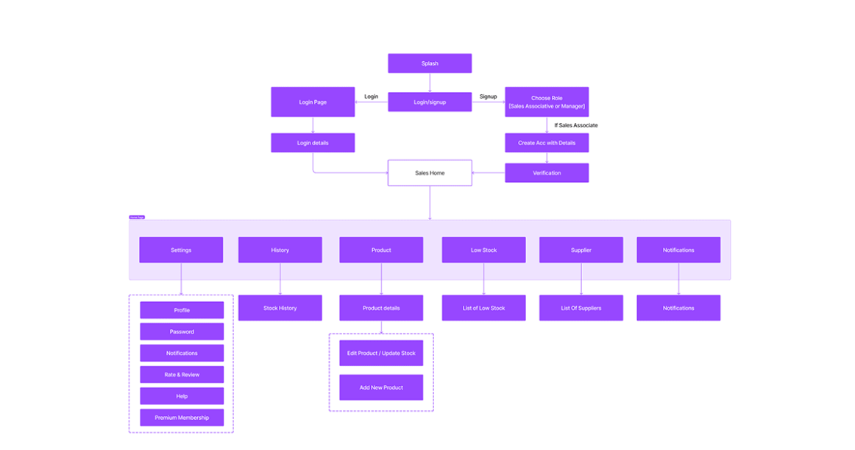**USER FLOW ER DIAGRAM.**

**CONTROLLER FLOW ER DIAGRAM**

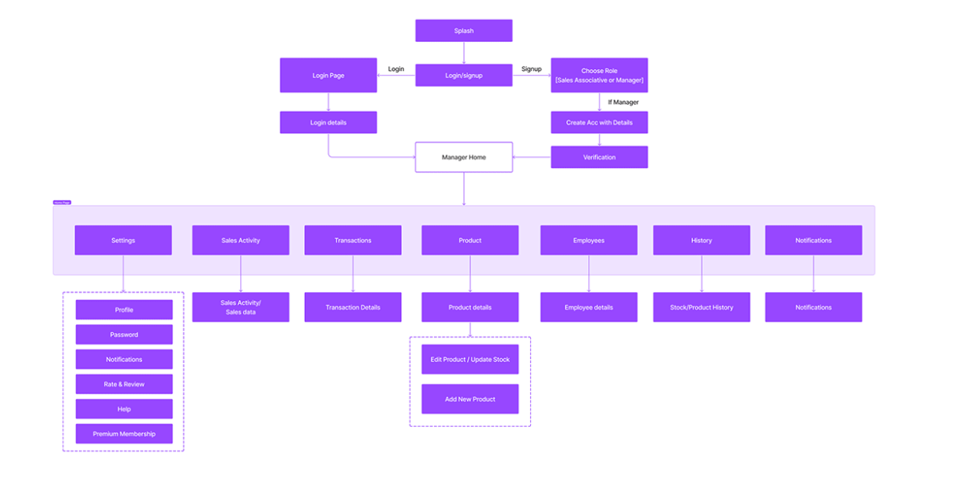

**UI/UX DESIGN**

